Aim: Study of interfacing using Mobile/web to publish or remotely access the data on the internet

Apparatus Required:
- Laptop / PC
- Smartphone
- Internet connection
- Blynk IoT platform (cloud-based)
Software Required:
- Blynk IoT Web Dashboard (https://blynk.cloud)
- Blynk Mobile Application

Theory:

The Internet of Things (IoT) is a system of interconnected devices that communicate and exchange data over the internet. These devices can be sensors, actuators, or controllers.
Blynk IoT platform provides a cloud-based environment that allows users to:
- Monitor data remotely
- Control devices using mobile/web interface
- Store and process data in real-time
Working Principle:
- The user interacts with the mobile/web dashboard
- Data is sent to the Blynk Cloud Server
- The cloud processes and stores the data
- Data is then accessed or displayed on another interface
In This Experiment:
- Virtual pins (V0, V1) act as communication channels
- Button widget → sends data
- Value widget → receives/displays data
- No physical hardware is required
System Architecture Explanation:
- Frontend: Mobile App / Web Dashboard
- Backend: Blynk Cloud Server
- Communication: Internet (WiFi)
- Interface: Virtual Pins
Procedure (Detailed):
- Open the Blynk IoT platform using a web browser.
- Create a new template and select:
  - Hardware: ESP8266
  - Connection: WiFi
- Save the template.
- Navigate to Datastreams section.
- Create two virtual datastreams:
  - V0 → Integer (Button control)
  - V1 → Integer (Data display)
- Open the Web Dashboard.
- Add widgets:
  - Button widget → linked to V0
  - Value/Label widget → linked to V1
- Configure button mode as Switch.
- Save the dashboard.
- Test the system by:
  - Toggling button (V0)
  - Manually updating value of V1
- Observe real-time updates on the dashboard.
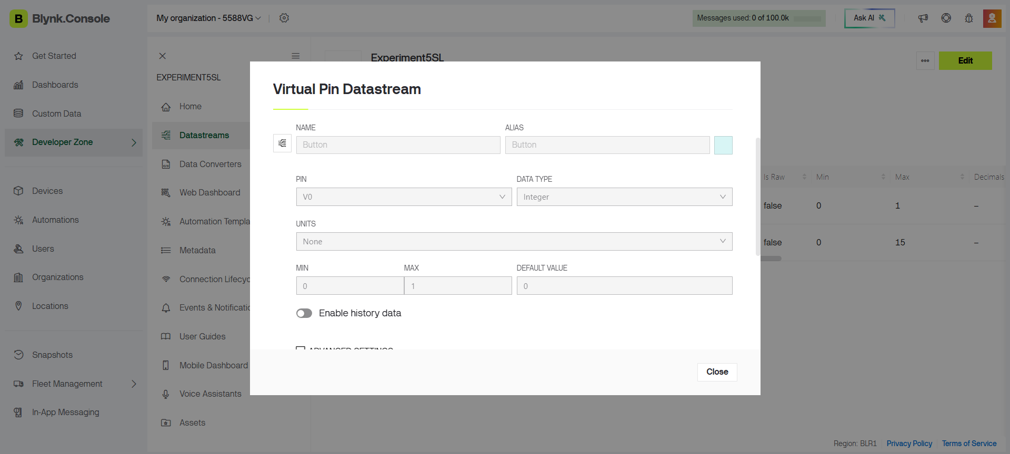
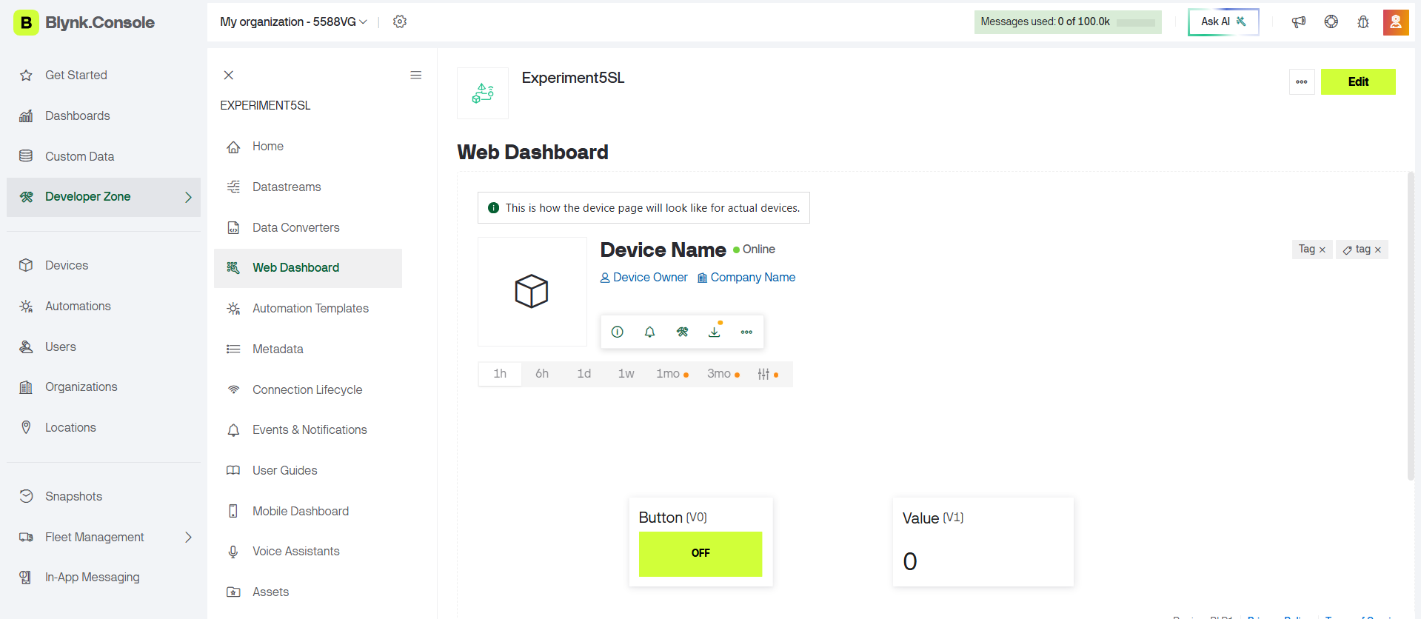

Observation (Detailed):
- When the button widget is pressed, data is transmitted to the cloud through virtual pin V0.
- The value widget displays the data received from virtual pin V1.
- Data transmission occurs instantly via internet connection.
- The web dashboard reflects changes in real-time.
- Remote access to data is successfully achieved without physical hardware.
- The system demonstrates bidirectional communication (send & receive).
Output:
- Button widget changes state (ON/OFF)
- Value widget displays updated values (0, 10, 50 etc.)
- Real-time synchronization between interface and cloud

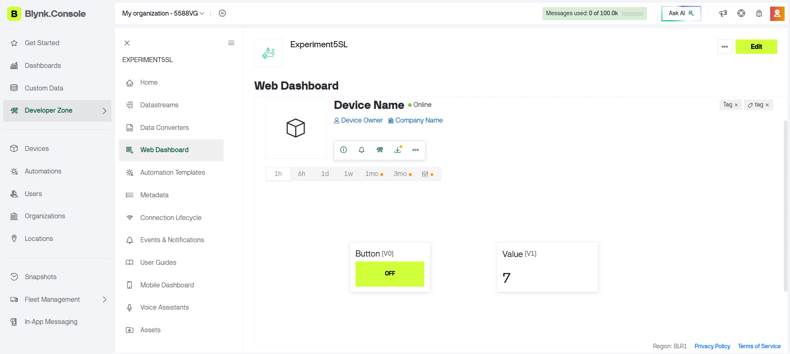
Result
The experiment to study interfacing using mobile/web applications for publishing and remotely accessing data over the internet was successfully performed using the Blynk IoT platform.

Conclusion
Successfully studied interfacing using Mobile/web to publish or remotely access the data on the internet

